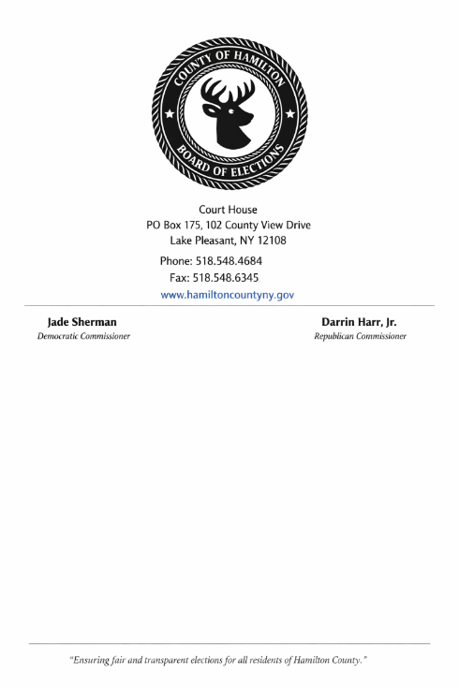

Court House
PO Box 175, 102 County View Drive
Lake Pleasant, NY 12108
Phone: 518.548.4684 | Fax: 518.548.6345
www.HamiltonCountyNY.Gov
Jade Sherman Darrin Harr, Jr.
Democratic Commissioner Republican Commissioner
09/20/2026

NOTICE TO CANDIDATES AND PARTY CHAIRS FOR 2026 GENERAL ELECTION
This correspondence will serve to advise you that you or your representative may attend any or all of the below Board of Elections activities.

- Inspection of Sample Ballots:
NYS Election Law §7-128(2)
You will have an opportunity to inspect the ballots to be used in the General Election.

This ballot inspection will occur on 9/18/26 and will take place at 102 County View Drive, Lake Pleasant, NY 12108 where the ballots may be viewed. Ballots are available on the county website at https://www.hamiltoncountyny.gov.

- Public Inspection and Pre-Election Testing of Machines:
NYS Election Law §§7-128(3), 7-207 & NYCRR §6210.2(d)(e)
You will have an opportunity to inspect voting machines and ballot marking devices to be used in the upcoming General Election and view the conduct of the logic and accuracy testing required to be performed on such voting machines and systems.

The inspection and pre-election testing will take place on 10/14/26 and will take place at 102 County View Drive, Lake Pleasant, NY 12108 where the county test decks will be run and machines may be viewed. Pre-election testing will continue daily, between the hours of 10:00 AM and 4:00 PM, until all pre-election testing has been completed.

- Rolling Canvass of Absentee, Accessible, Early Vote by Mail, Special, Federal and Military Ballots:
NYS Election Law §9-209(1)(2)
The rolling canvass of absentee, accessible, early vote by mail, special, federal and military ballots will begin within 4 days of receipt. The canvass starting date is on 9/20/26 at 10:30 AM and will take place at 102 County View Drive, Lake Pleasant, NY 12108. The canvass of these ballots will continue Tuesdays and Fridays. There will be one team conducting the canvass, between the hours of 10:30 AM and 4:00 PM, until all ballots have been canvassed.

On or after Election Day, the canvass will be conducted within one day of receipt. The canvass shall end no later than 11/16/26 at 10:30 AM and will take place at 102 County View Drive, Lake Pleasant, NY 12108.

- Scanning of Canvassed Ballots Prior to Election Day:
NYS Election Law §9-209(6)(b)(c)
Ballots canvassed during this time period will be scanned on 10/23/26 at 10:00 AM. Ballot types as described above received after this date will continue to be canvassed Tuesdays and Fridays, and those ballots will be scanned after the close of polls on the last day of early voting will be scanned on 11/02/26 at 10:00 AM.

- Scanning of Canvassed Ballots Post Election Day:
NYS Election Law §9-209(6)
The scanning of ballots canvassed after Election Day will continue 11/16/26 10:00 AM and will take place at 102 County View Drive, Lake Pleasant, NY 12108.

- Review Invalid Absentee, Accessible, Early Vote by Mail, Military, Special, Undeliverable and Defects Not Cured Timely:
NYS Election Law §9-209(8)(a)
Within four business days after Election Day, the county will review the Absentee, Early Mail, Military and Special Ballots found to be invalid, undeliverable or containing defects that have not been timely cured. This review will take place on 11/09/26 and will occur at 102 County View Drive, Lake Pleasant, NY 12108.

- Canvass and Casting of Affidavits:
NYS Election Law §9-209(7)(a)
The county will canvass the Affidavits four business days after Election Day. This canvass will take place on 11/09/26 10:00AM and will occur at 102 County View Drive, Lake Pleasant, NY 12108.

- Post-Election Audit for Election Day and In Person Early Voting:
NYS Election Law §9-211 & NYCRR §6210.18
The post-election audit of randomly selected voting machines will begin on 11/04/26 at 10:00am and will take place at 102 County View Drive, Lake Pleasant, NY 12108 where the county audit will occur. This audit will continue daily, with One team conducting the audit, between the hours of 10:00 AM and 4:00pm PM, until all selected voting machines have been audited.

The drawing which will randomly select the voting machines that must be audited will take place on 11/04/26 at 10:00 AM and will occur at 102 County View Drive, Lake Pleasant, NY 12108 where the county drawing will occur. The audit shall commence on the same day as the random manual selection process.

- Scanners Used to Count Absentee/Early Vote by Mail Ballots Prior to Election Day (Audit):
NYS Election Law §9-211(2)
The scanner(s) will be audited from three percent of Election Districts within three days after any Election Day (Early Canvassed Ballots). This audit will take place on 11/05/26 at 10:00 AM and will occur at 102 County View Drive, Lake Pleasant, NY 12108.

- Recanvass:
NYS Election Law §9-208
The recanvass of all voting machines will begin on 11/09/26 at 10:00 AM and will take place at 102 County View Drive, Lake Pleasant, NY 12108 where the county recanvass will occur. This recanvass of these ballots will continue daily, with One team conducting the recanvass, between the hours of 10:00 AM and 4:00 PM, until all voting machines have been recanvassed.

- Manual Recount:
NYS Election Law §9-208(4)
Following the completion and announcement of the results of the recanvass of all ballots, the Board of Elections will conduct a full manual recount of all ballots for a particular contest if the margin of victory is twenty votes or less or 0.5% or less. You will receive notice by mail of the date, time and processes for the manual recount should the office you are running for fall into this category.

